**Use Case for Procurement Requestor - My Request**

**Actors: Requestor**

**Description:**

* To provide requestors with a comprehensive "My Request" dashboard, enabling them to view and manage their procurement requests efficiently. The dashboard includes key components such as creating a new request, filtering requests based on various criteria, searching for specific requests, and taking action on requests. Users can also navigate through pages and access detailed information for each request.

**Trigger Point:**

* The trigger point for this use case is when a procurement requestor wants to access and manage their existing requests.

**Precondition:**

* The user must have valid login credentials and appropriate access rights to access the "My Request" section.

**Normal Flow:**

**1 Login:**

* The requestor logs in to the procurement requestor portal using valid credentials.

**2 Access My Request Dashboard:**

* The requestor navigates to the "My Request" section.

**3 Top Panel Overview:**

* The top panel displays the following options:
* "Create New Request" button to initiate a new procurement request.
* Numbers and categories for "All Request," "Pending Request," "Reject Request," "Approve Request," and "On Hold Request.



**4 Filtering Requests:**

* The requestor interacts with the "Filter" dropdown button to select filtering criteria such as location, request type, creation date, delivery date, total cost, priority, and action status.

**5 Search Functionality:**

* The requestor searches for specific requests using the "Search" function, entering keywords such as username or date.

**6 Status Action**:

* The requestor selects an action status from the dropdown menu, choosing from options like "Pending," "Approve," "Reject," or "On Hold."

**7 Location, Request Type, Creation Date, Delivery Date, Total Cost, Priority:**

* The requestor utilizes dropdown menus and input fields to filter requests based on specific criteria such as location, request type, creation date, delivery date, total cost, and priority.

**8 Action Icons:**

* The requestor clicks on icons associated with each request to perform actions like viewing details, approving, rejecting, or putting a request on hold.

**9 Pagination:**

* The requestor navigates through pages using the "Previous Page" and "Next Page" options to view additional requests.

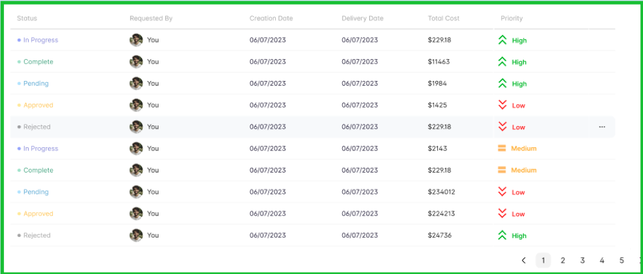**Post Condition:**

* Upon performing actions or applying filters, the system updates the display to reflect the chosen criteria. Any changes made to the request status are reflected in the system.

**Alternative Flow:**

**1 Invalid Login:**

* If the user enters incorrect login credentials, the system triggers an authentication error message, prompting the user to enter valid credentials.

**2 No Matching Requests:**

* If the search or filter criteria do not match any requests, the system triggers a notification indicating no matching requests.

**3 Error in Action:**

* If there is an error in performing an action (e.g., approval, rejection), the system triggers an error message, guiding the user to correct the information.

**Benefits:**

* Efficient Request Management: Users can quickly filter, search, and take action on their procurement requests.
* Clear Status Overview: The top panel provides a quick summary of request status categories.
* Flexible Filtering: Dropdown menus and input fields allow users to filter requests based on various criteria.
* User-Friendly Pagination: Users can navigate through multiple pages seamlessly.
* By following this use case, organizations can ensure that requestors have a robust and user-friendly interface for managing their procurement requests effectively.